**Smith MSIS Alumni Contact Information Database Project**

an organized cataloging system for alumni information

**Table of Content**

* **General Info**
* **Technologies**
* **Launch and Instructions**
* **Example of use and illustration**
* **Source**

**General Info**

The purpose of Terps Ocean’s database is to provide a well-organized cataloging system that accounts for the contact information of all the MS Information Systems alumni of University of Maryland Robert. H. Smith School of Business and meet various customer needs based on accurate and adequate data.

**Technologies**

Project is created with:

* SQL
* HTML
* Power BI
* Excel

**Launch**

Required Hardware and Software:

* A PC or Mac that is connected to Internet
* Installed Web Browser. To get the best experience, we suggest using Chrome, Safari or Firefox. IE10 or higher is supported

**Instructions**

**There are three ways to launch Terps Ocean online Application**

**Option A**

1. Find the file “Project0504-08_Ouput Terps Ocean.html”

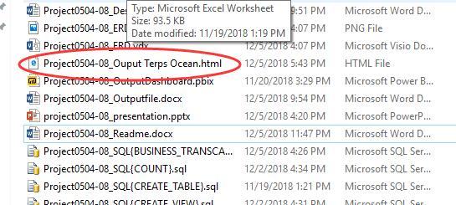

1. Open the “Project0504-08_Ouput Terps Ocean.html” to be access to the website

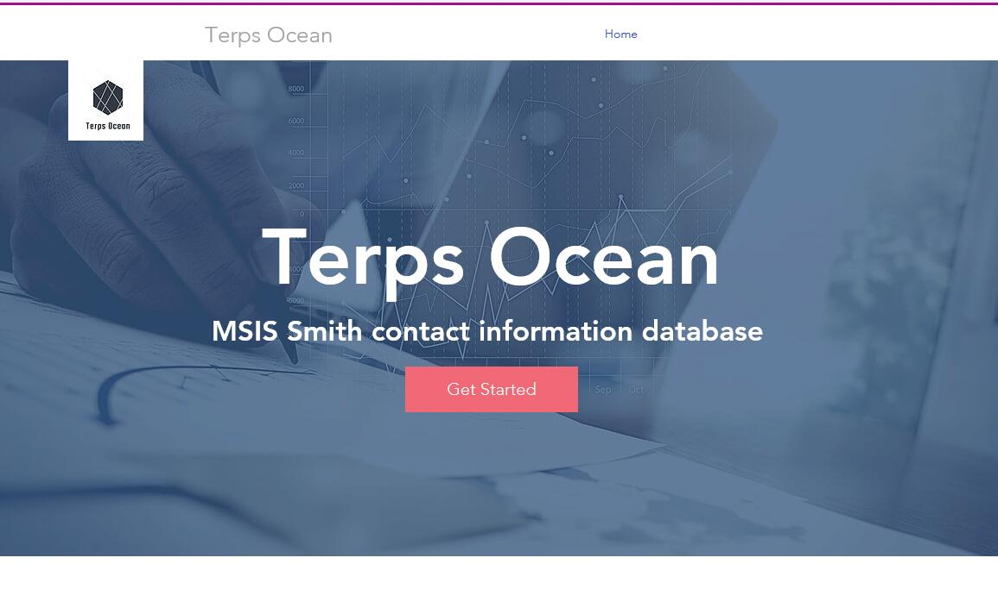

**Option B**

1. Type “<https://826001623.wixsite.com/terps-ocean>” In any browser to be access to the website

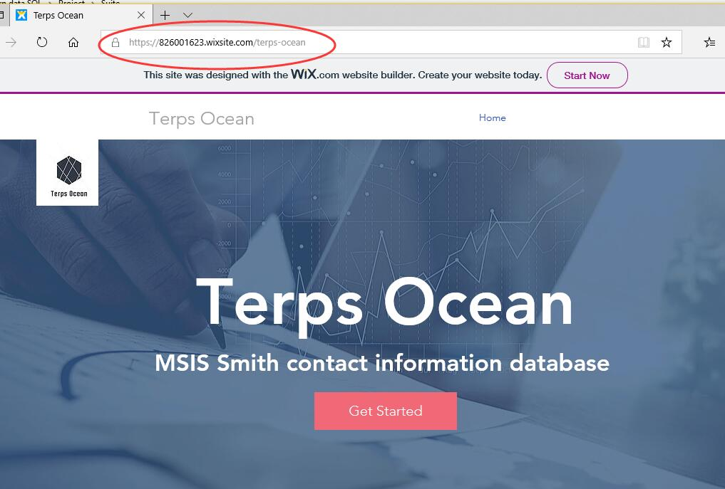

**Option C**

1. Create a txt file
2. Type HTML:

“<head>

<meta http-equiv="refresh" content="0;url=https://826001623.wixsite.com/terps-ocean">

<head>”

Into the txt file and save it as **“.html” file**

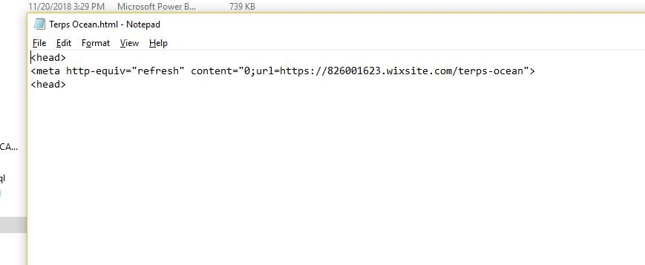

1. Open the .html file you just created to be access to the website



**After launch the website**

1.Explore the database by clicking ‘Get Started’

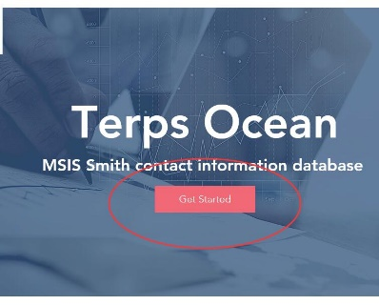

2.Five functional windows will be showed up, view statistics by clicking into different windows and sorting the columns on the right side of the website

**Illustrations**

1. The overview. The five charts interact to each other. By clicking one item in any chart, the remaining charts will change accordingly.

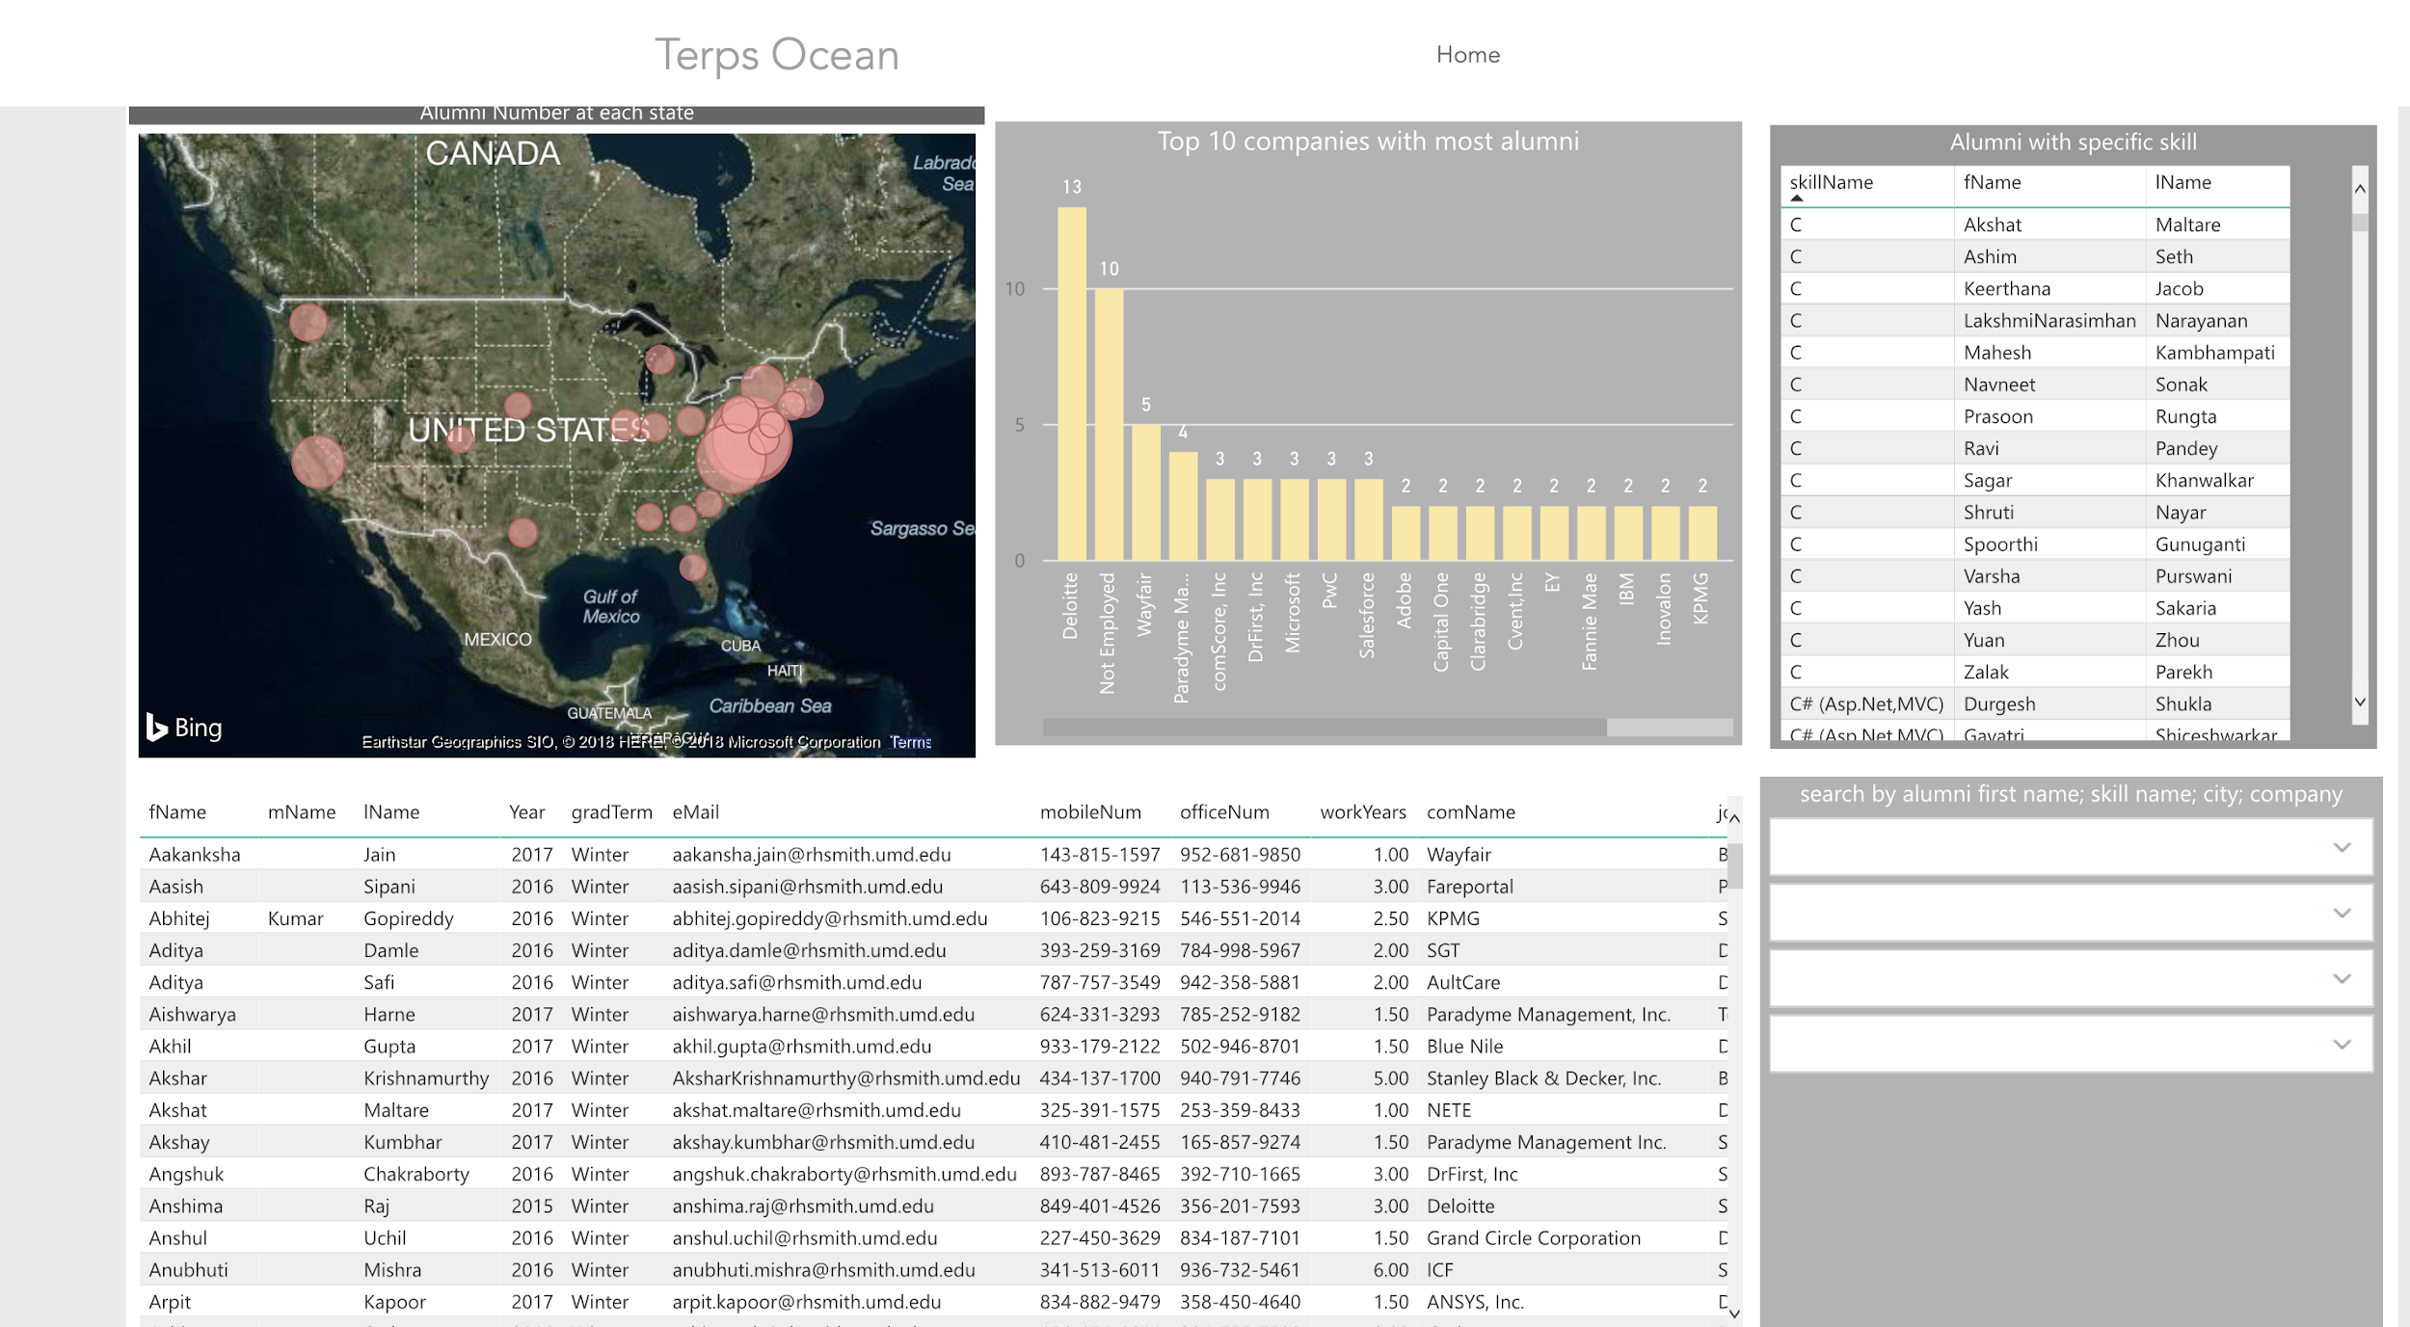

1. Alumni Heat Map. By clicking different circles, total numbers of alumni in this state will show up

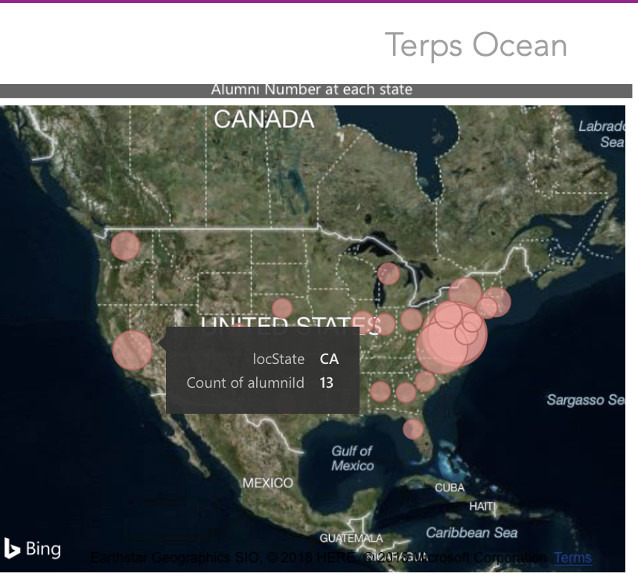

1. The Top 10 company chart shows the statistic for alumni’s working company. By choosing the company on the bar, the interface shows how many alumni works in the company.

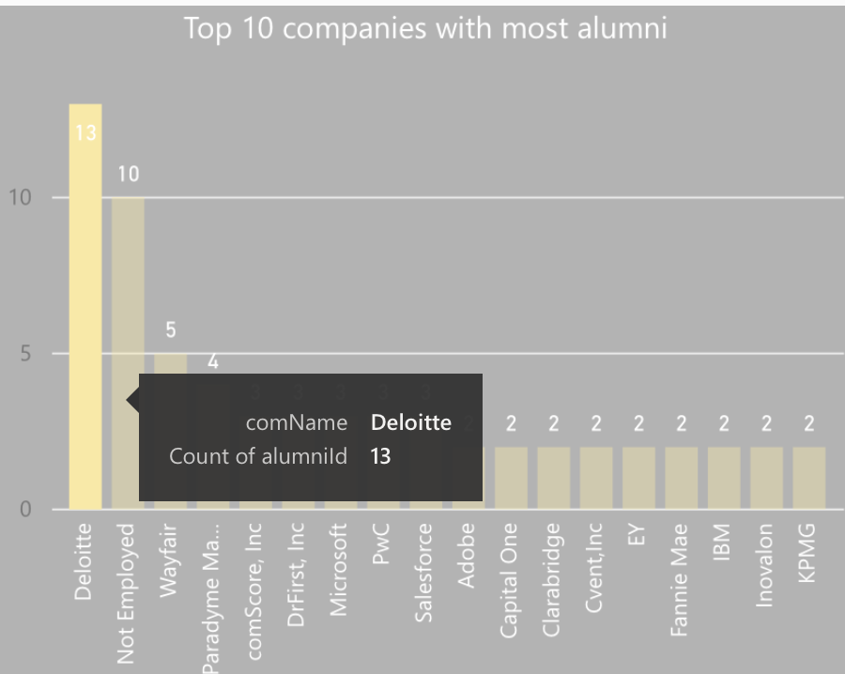

1. Skill Chart for Alumni. By clicking any row, the corresponding information will show in Alumni Map and Top 10 company chart.

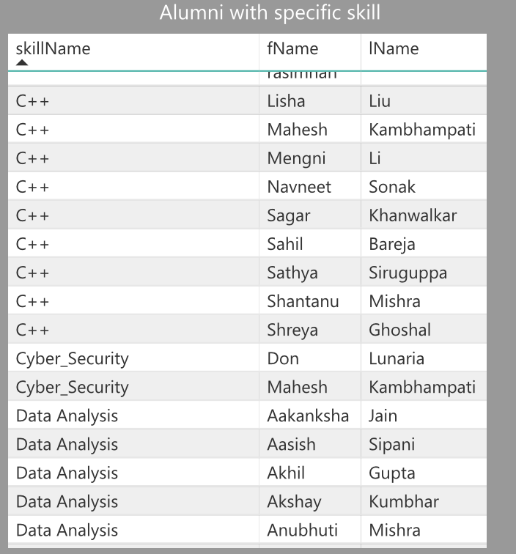

1. By clicking any names, the location, company, and skill of him/her will show up.

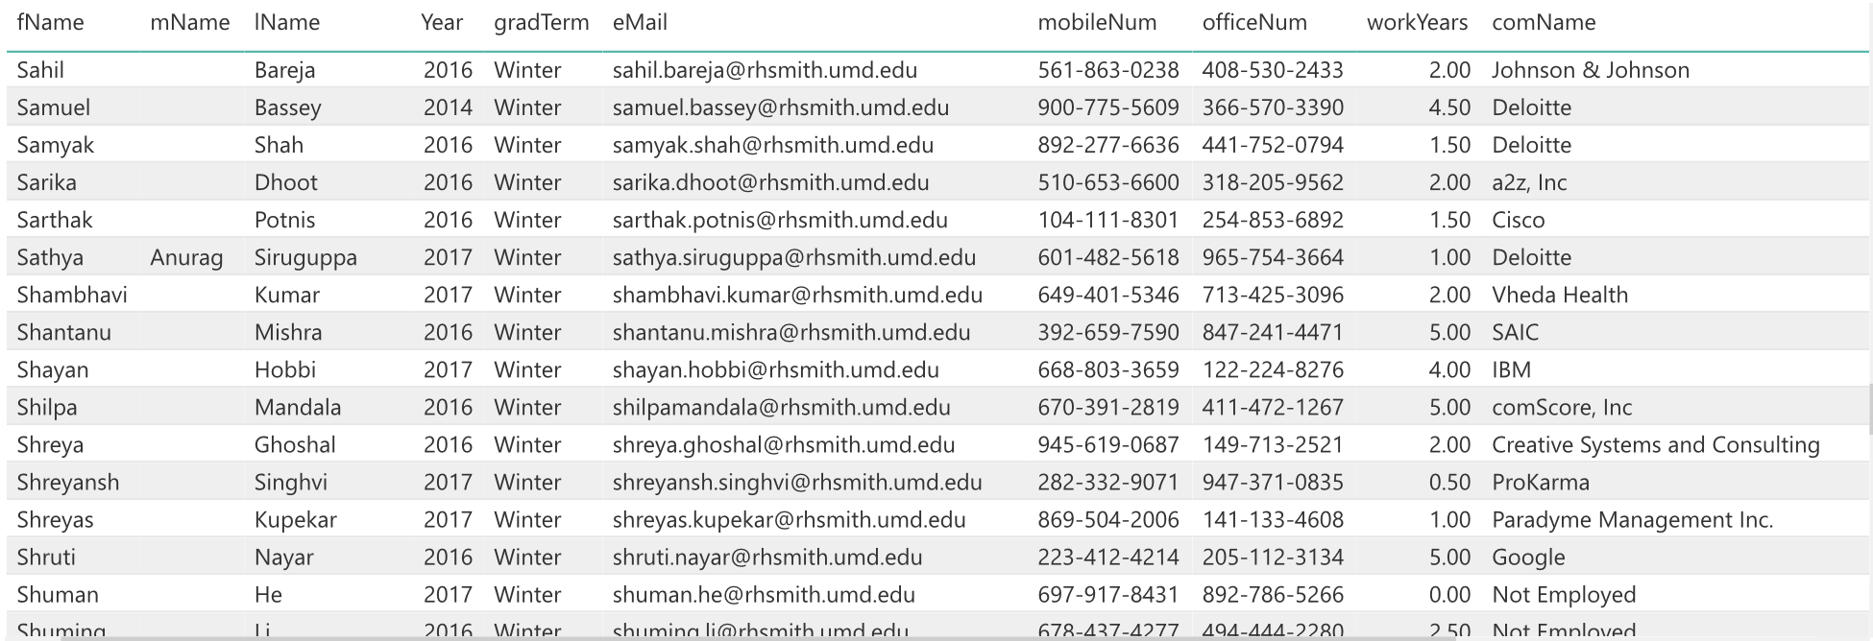

1. Search bar chart. Fill in the four rows by alumni first name, skill name, city and company by using the drop-down list or type in accordingly, the other four charts will display. To clear the filter, simply click the erase button on the right side

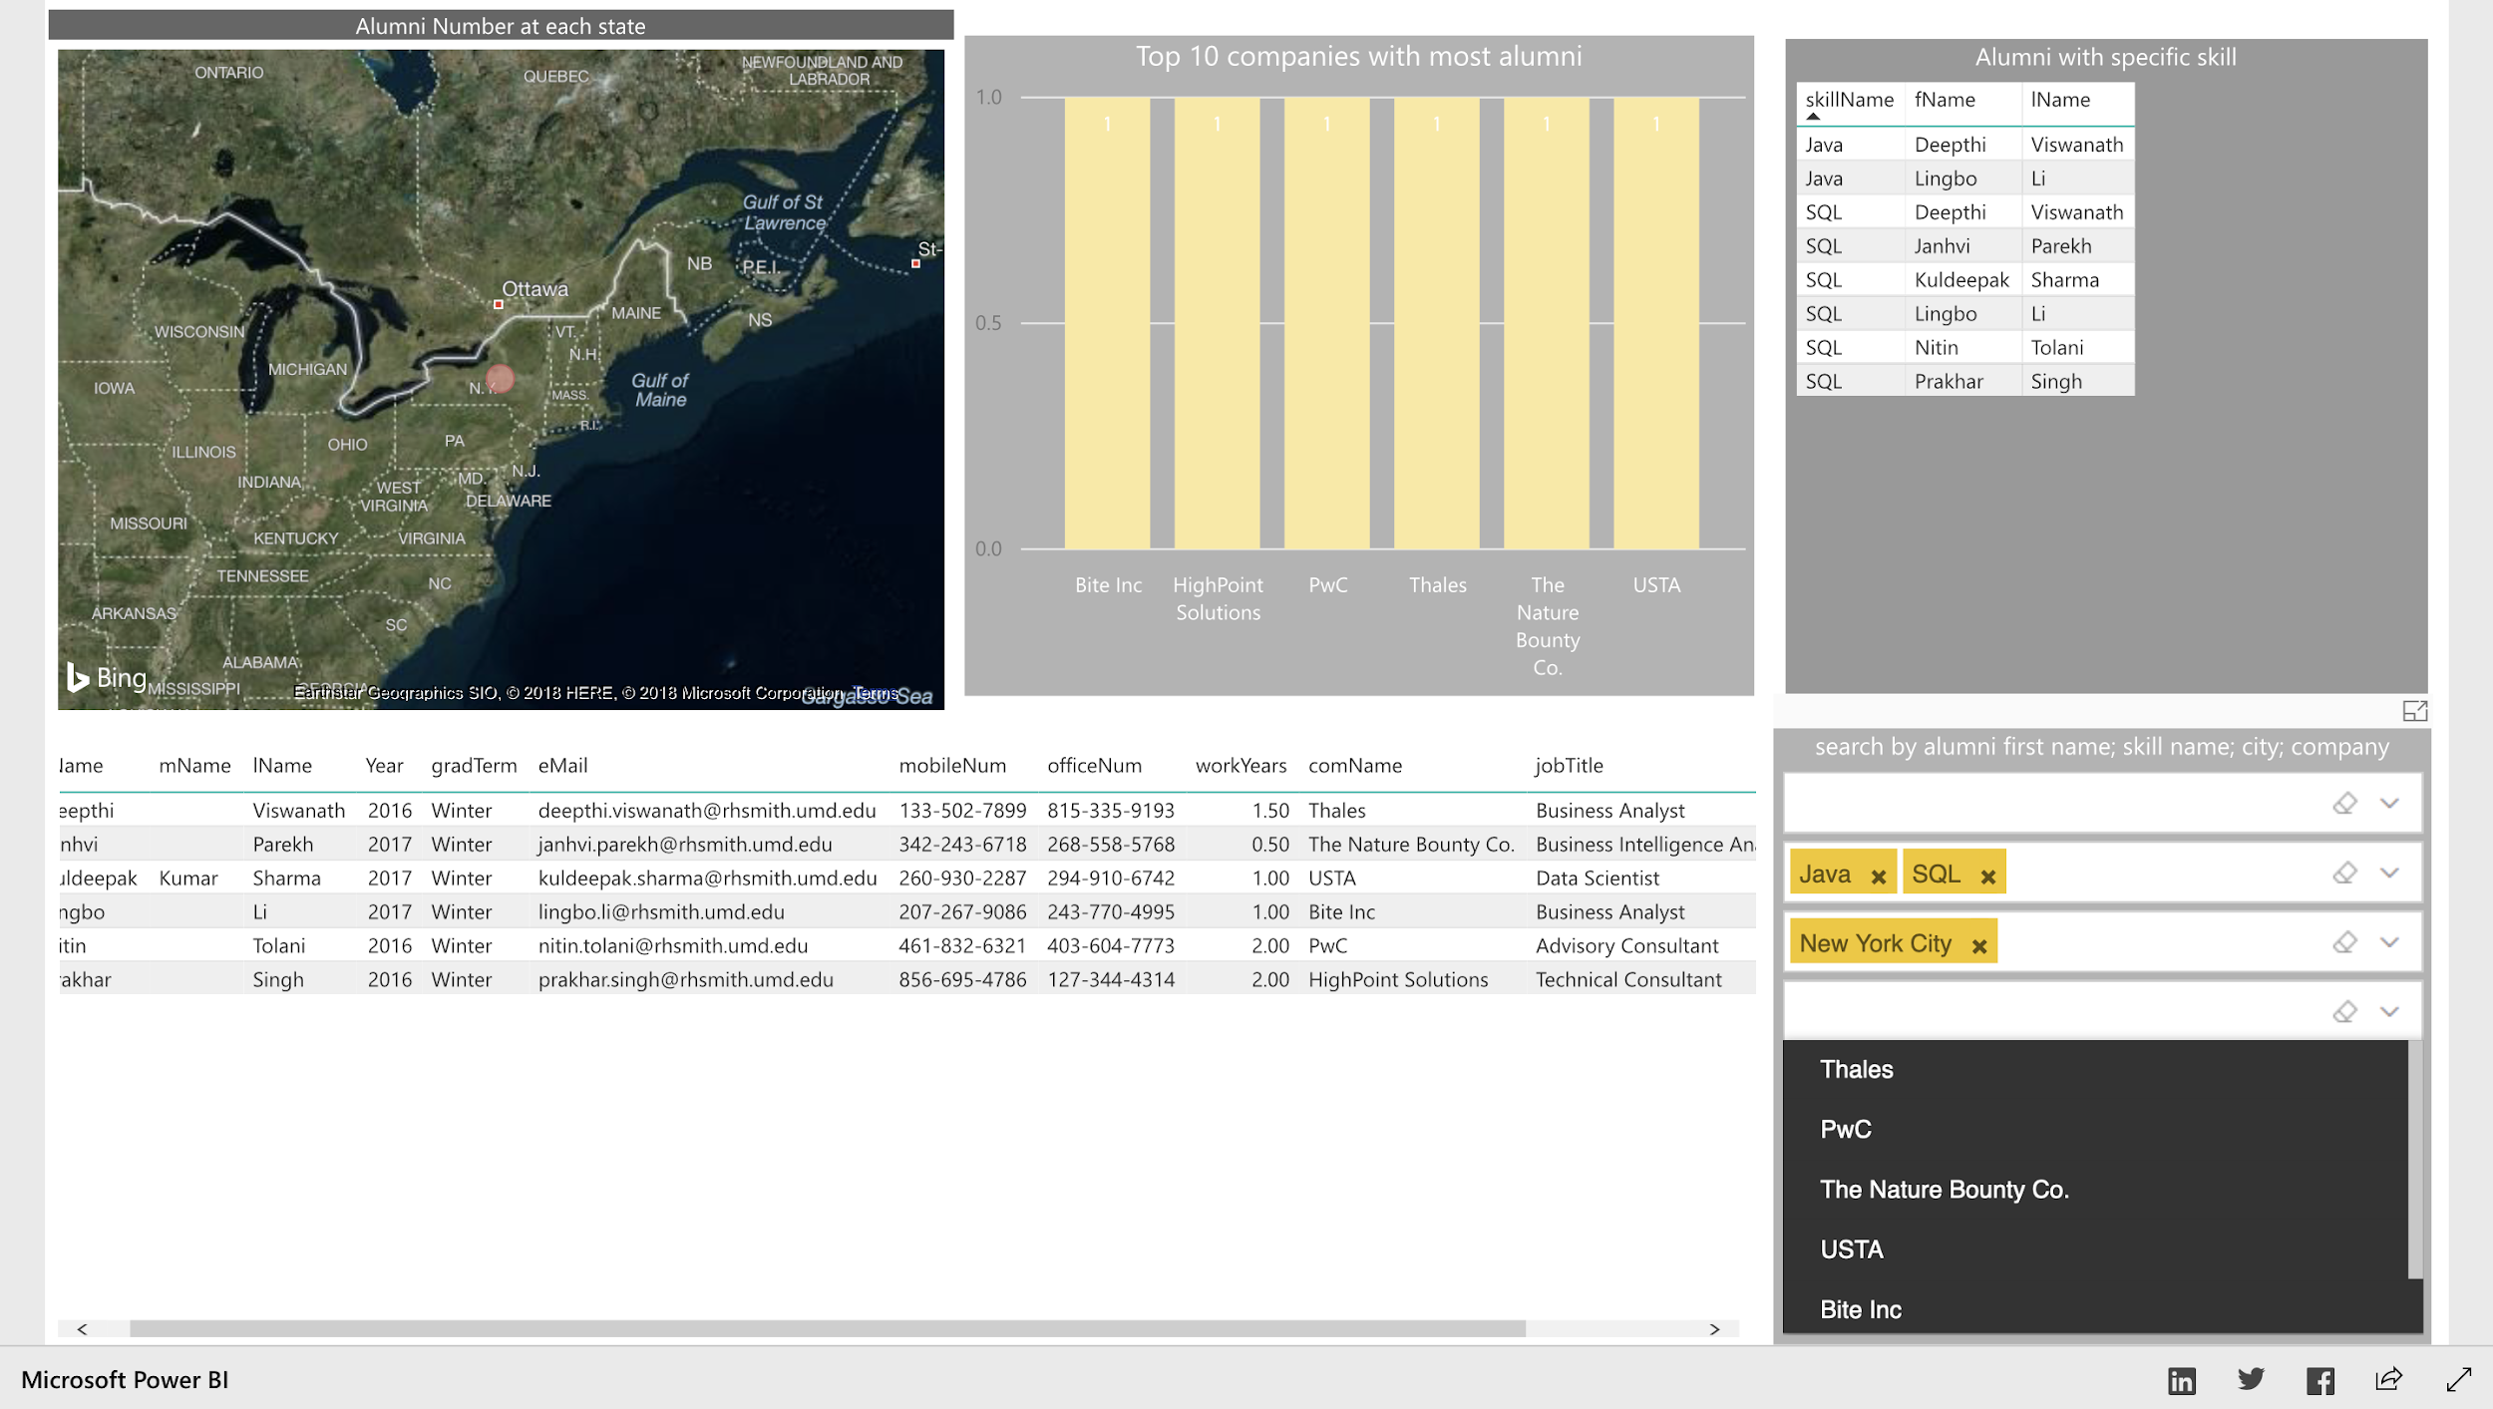

#### **Examples of use**

As an alumni association vice president, I want to know alumni in California state that have SQL skills.

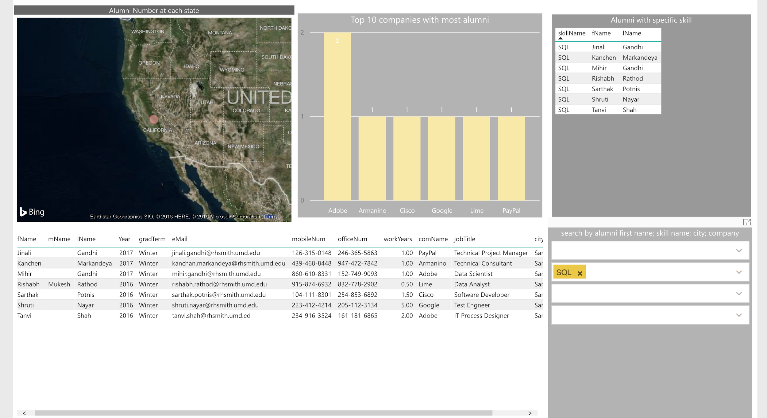

#### **Sources:**

[https://www.linkedin.com](https://www.linkedin.com/feed/)

**HTML code for portal file:**

<head>

<meta http-equiv="refresh" content="0;url=https://826001623.wixsite.com/terps-ocean">

<head>

**Power BI dashboard source code:**

<https://app.powerbi.com/view?r=eyJrIjoiMjc4Y2UwNjItZmFkMy00YmUyLWJiYTktODY5N2RkNjcyNDI4IiwidCI6ImM2YmEzMzM4LTNkY2YtNGQ3OC04Y2I1LWU5M2UxMjU3ZDNkYSIsImMiOjN9>

**Power BI HTML embed code:**

<iframe width="1024" height="786" src="https://app.powerbi.com/view?r=eyJrIjoiMjc4Y2UwNjItZmFkMy00YmUyLWJiYTktODY5N2RkNjcyNDI4IiwidCI6ImM2YmEzMzM4LTNkY2YtNGQ3OC04Y2I1LWU5M2UxMjU3ZDNkYSIsImMiOjN9" frameborder="0" allowFullScreen="true"></iframe>